**Step1:** Login azure account

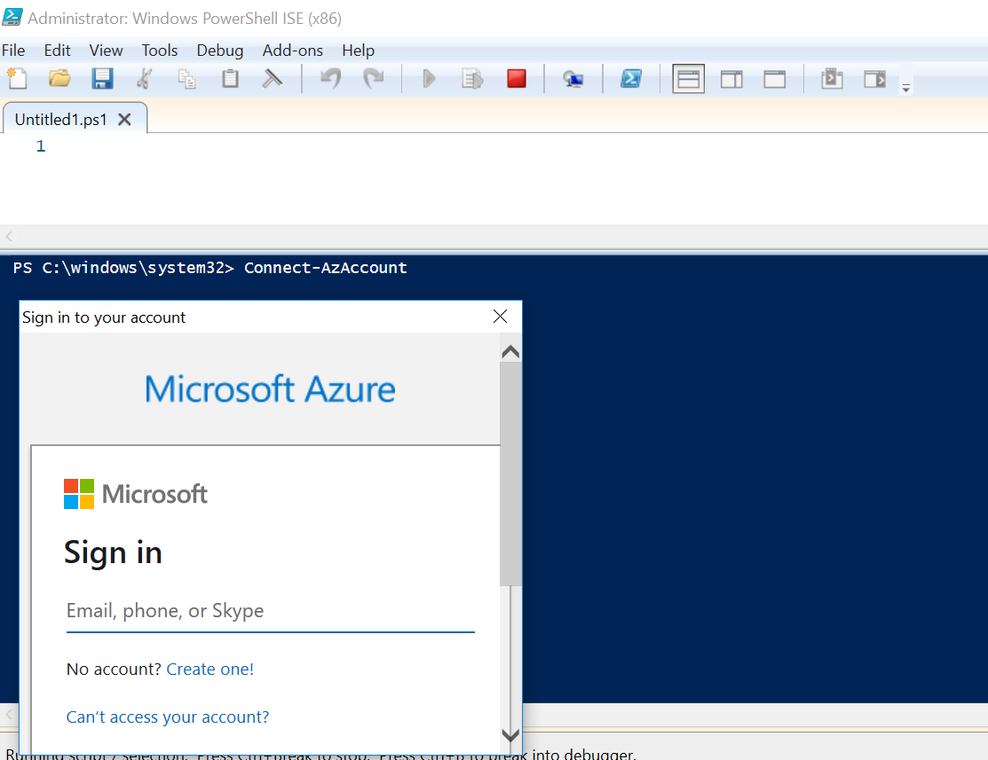

**Step2:** Paste the attached PowerShell script to download all the resources



**Step3:** After runs the PowerShell script, it will create following folder

**C:\AzureInventory**

**Step4:** Go to given folder to get all resources as CSV file

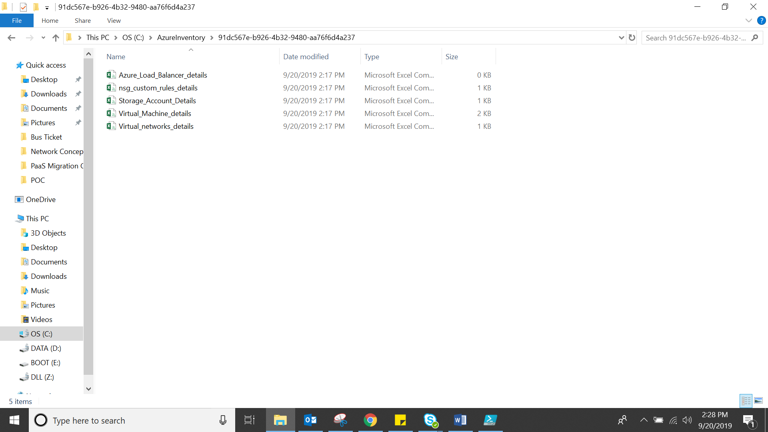

**Step5:** Attached download file for reference

